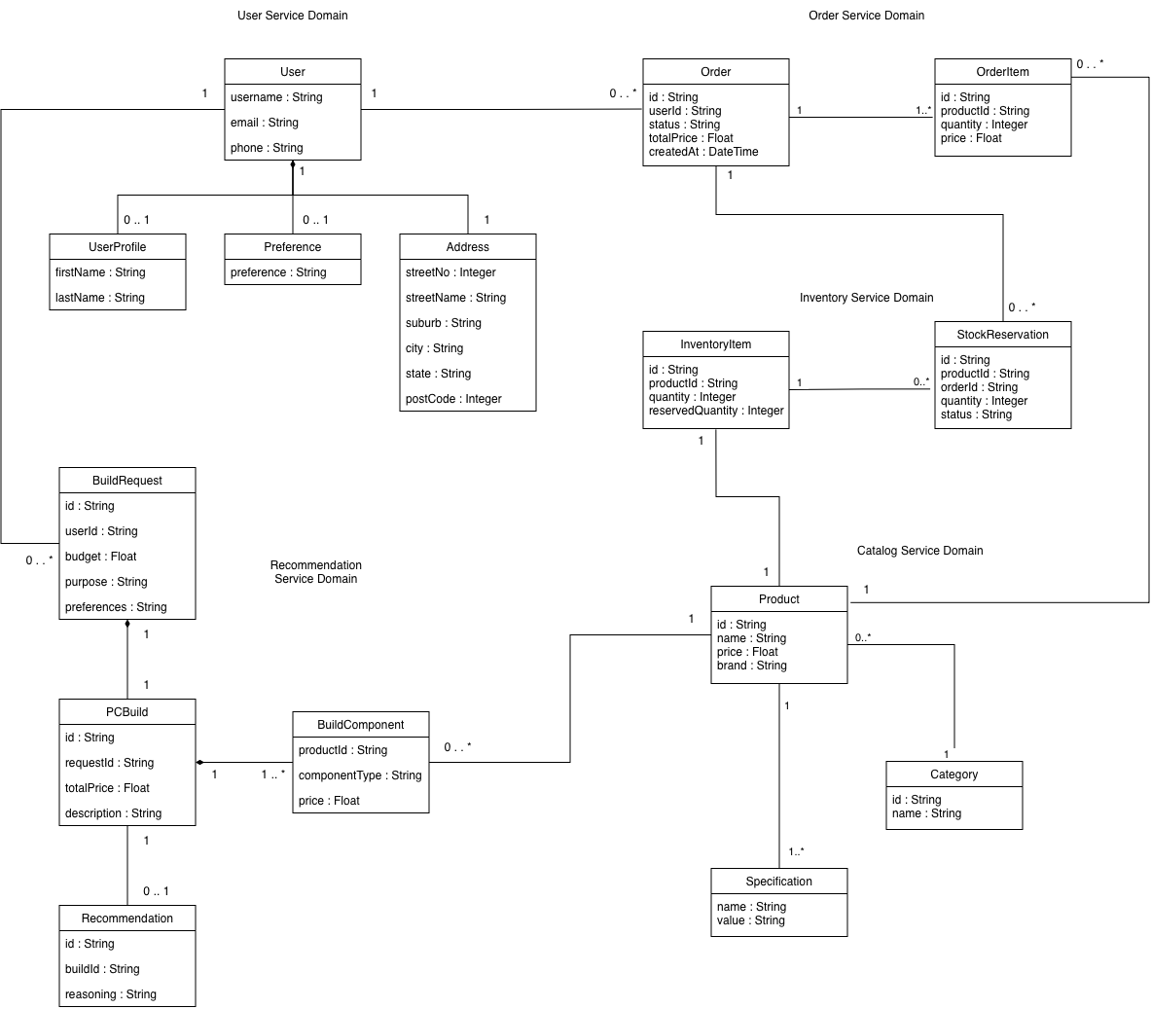

Domain Classes and Link to User Stories

Service | User Story | Domain Classes
Catalog Service | FR-01, FR-02, FR-03, FR-04, FR-05 | Product, Category, Specification
Inventory Service | FR-02, FR-06, FR-07, FR-08, FR-11 | InventoryItem, StockReservation
Order Service | FR-06, FR-09, FR-10, FR-11, FR-12, FR-13, FR-14, FR-20 | Order, OrderItem
Account Service | FR-10, FR-13, FR-15, FR-16, FR-17 | User, User Profile, Preference, Address
Recommendation Service | FR-17, FR-18, FR-19, FR-20, FR-21 | BuildRequest, PCBuild, BuildComponent, Recommendation

Domain Class | Type | Description
Product | PC product or component available in the product catalog | Aggregate Root / Entity
Category | Product category used to organise related PC components | Aggregate Root / Entity
Specification | Technical attributes and specifications of a product | Value Object
InventoryItem | Stock record for a product; maintains quantity and availability | Aggregate Root / Entity
StockReservation | Temporary stock allocation created during checkout | Entity
Order | Customer purchase; manages the order lifecycle and fulfilment status | Aggregate Root / Entity
OrderItem | Individual product and quantity included in an order | Entity
User | Registered customer account and authentication information | Aggregate Root / Entity
UserProfile | Personal profile details associated with a user | Value Object
Preference | Saved customer preferences used for PC build recommendations | Value Object
Address | Saved customer delivery address | Entity
BuildRequest | Customer request containing budget, intended use, and preferences for a PC build | Aggregate Root / Entity
PCBuild | Complete PC configuration consisting of selected components | Aggregate Root / Entity
BuildComponent | Individual PC component included in a build | Entity
Recommendation | Generated PC build recommendation associated with a customer request | Entity

Catalog Service Domain Model

1.1 Product

Field Name | Type | Description | Constraints
id | String | Unique Identifier of each product | Primary Identifier
name | String | Product Name | Required
price | Float | Price of the item | Required
brand | String | Brand the item belongs to | Required

1.2 Category

Field Name | Type | Description | Constraints
id | String | Unique identifier of the category of item | Primary Identifier
name | String | Name of category item belongs to | Required

1.3 Specification

Field Name | Type | Description | Constraints
name | String | Name of the specification | Required
value | String | Specification Value | Required

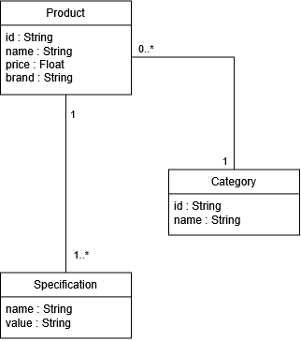

Inventory Service Domain Model

2.1 InventoryItem

Field Name | Type | Description | Constraints
id | String | Unique identifier of each item | Primary Identifier
productId | String | Identifier of the product in the Catalog Class | Required
quantity | Integer | Total quantity of the product currently in stock | Required
reservedQuantity | Integer | Quantity currently reserved for orders | Required

2.2 StockReservation

Field Name | Type | Description | Constraints
id | String | Unique identifier of each reservation | Primary Identifier
productId | String | Identifier of the product being reserved | Required
orderId | String | Identifier of the order the stock is reserved for | Required
quantity | Integer | Quantity of the product reserved for the order | Required
status | String | Current status of the reservation | Required

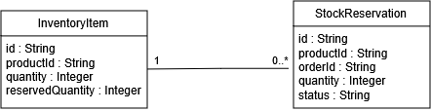

Order Service Domain Model

3.1 Order

Field Name | Type | Description | Constraints
id | String | Unique identifier of each order | Primary Identifier
userId | String | User ID of the account the order was placed | Required
status | String | Status of the order (cancelled/placed/completed) | Required
totalPrice | Float | Total price of all order items | Required
createdAt | DateTime | Date and Time of the order | Required

3.2 OrderItem

Field Name | Type | Description | Constraints
id | String | Unique identifier of order item | Primary Identifier
productID | String | Unique identifier of product | Required
quantity | Integer | Number of order items | Required
unitPrice | Float | Price of each order item | Required

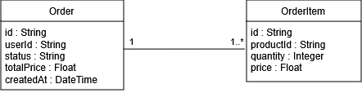

Account Service Domain Model

4.1 User

Field Name | Type | Description | Constraints
username | String | Unique identifiers for each user | Primary Identifier
email | String | Email of user | Required
phone | String | Phone number of the user | Required

4.2 UserProfile

Field Name | Type | Description | Constraints
firstName | String | First name of the user | Optional
lastName | String | Last name of the user | Optional

4.3 Preference

Field Name | Type | Description | Constraints
preference | String | User preferences for the recommendation service | Optional

4.4 Address

Field Name | Type | Description | Constraints
streetNo | Integer | Street number of the user’s address | Required
streetName | String | Street name of the user’s address | Required
suburb | String | Suburb of the user’s address | Required
city | String | City of the user’s address | Required
state | String | State of the user’s address | Required
postCode | Integer | Post code of the user’s address | Required

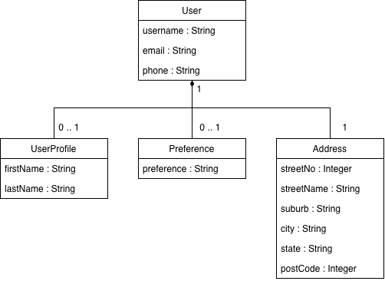

Recommendations Service Domain Model

5.1 BuildRequest

Field Name | Type | Description | Constraints
id | String | Unique identifier of each build request | Primary Identifier
userId | String | Identifier of the user requesting the PC build | Required
budget | Float | Maximum budget for the requested PC build | Required
purpose | String | Intended use of the PC, such as gaming, work, or content creation | Required
preferences | String | Additional user preferences for the PC build | Optional

5.2 PCBuild

Field Name | Type | Description | Constraints
id | String | Unique identifier of each PC build | Primary Identifier
requestId | String | Identifier of the build request used to generate this build | Required
totalPrice | Float | Total price of all components in the PC build | Required
description | String | AI-generated summary of the PC build | Required

5.3 BuildComponent

Field Name | Type | Description | Constraints
productId | String | Identifier of the product selected for the PC build | Required
componentType | String | Type of PC component, such as CPU, GPU, RAM or motherboard | Required
price | Float | Price of the component when the build was generated | Required

5.4 Recommendation

Field Name | Type | Description | Constraints
id | String | Unique identifier of each recommendation | Primary Identifier
buildId | String | Identifier of the PC build associated with the recommendation | Required
reasoning | String | AI-generated explanation of why the selected PC build is suitable for the user's requirements | Required
